Developing a Model Using Regression Analysis

Section A – Group 4

Chandrayee Bose, Karan Pratap Singh Gill, Nitin Gupta, Samarth Agarwal, Utkarsh Jain

1

Overview

The objective of the assignment is to develop a Linear Regression model and interpret the results. Two datasets are given - one of White Wine and other on Red Wine. The datasets describe the various aspects of the quality of wine. We are required to find out the factors important in determining the quality of wine based on interpretation of results.

White Wine Dataset

Cleaning Data

Initial Data has 4898 observations with 12 columns.

- Removing Duplicate Observations

Now, the new data has 3961 observations with 12 columns.
2
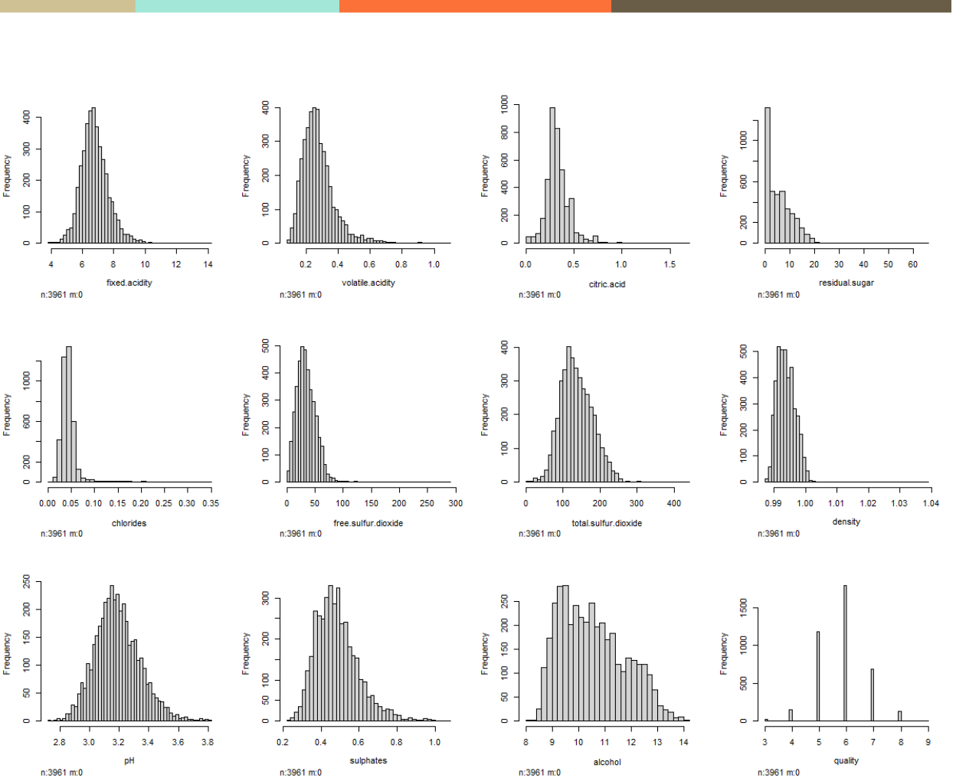

Fig 1: Distribution of each column of dataset

Each column (variable) is fairly distributed.

Removing outliers from all columns (Outside of 1.5x interquartile range)

So updated data has 3301 observations with 12 columns.
3
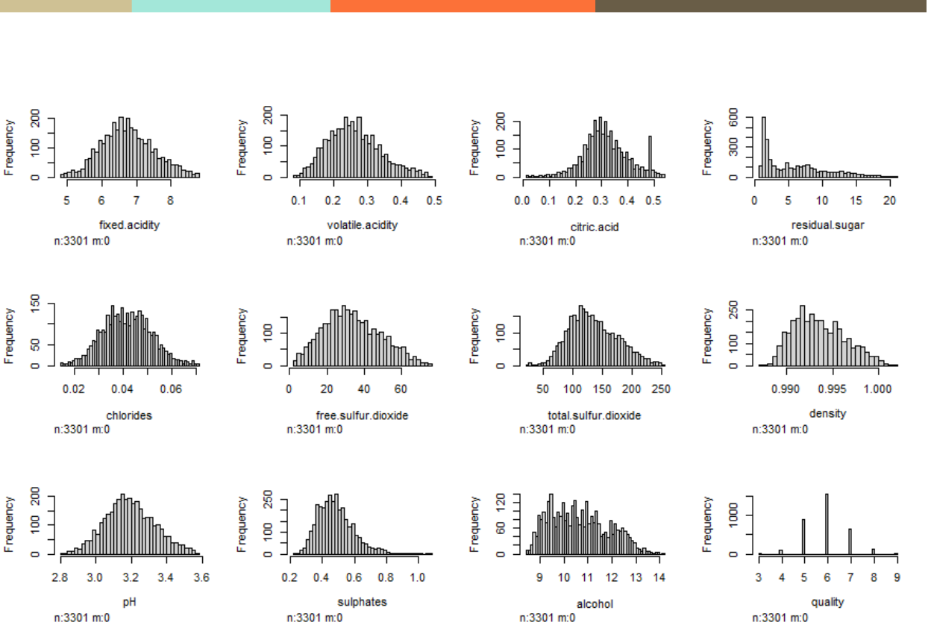

Fig 2: Distribution of White wine after cleaning the data

No missing value treatment required and no need to change the type of variables.
4

Exploratory Data Analysis
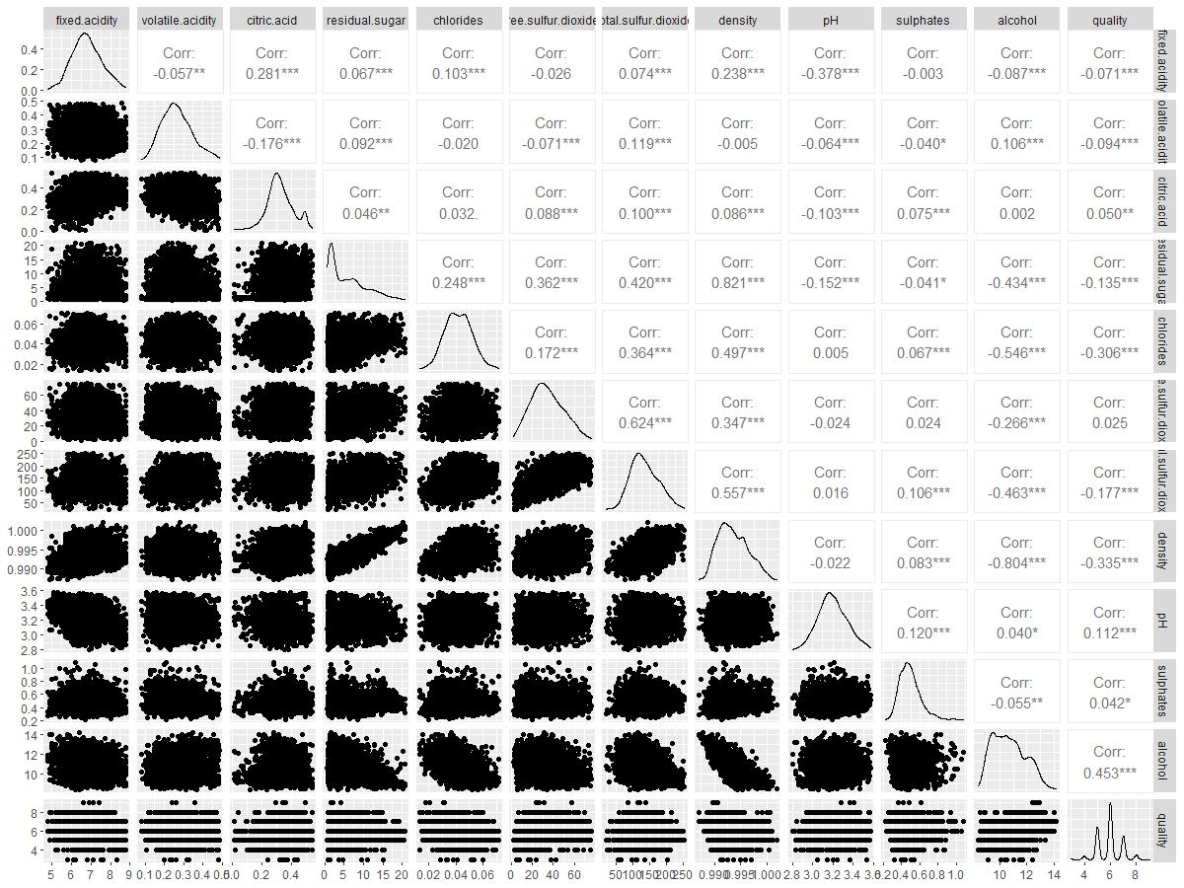

Fig 3: EDA of white wine dataset
5

Correlation Matrix
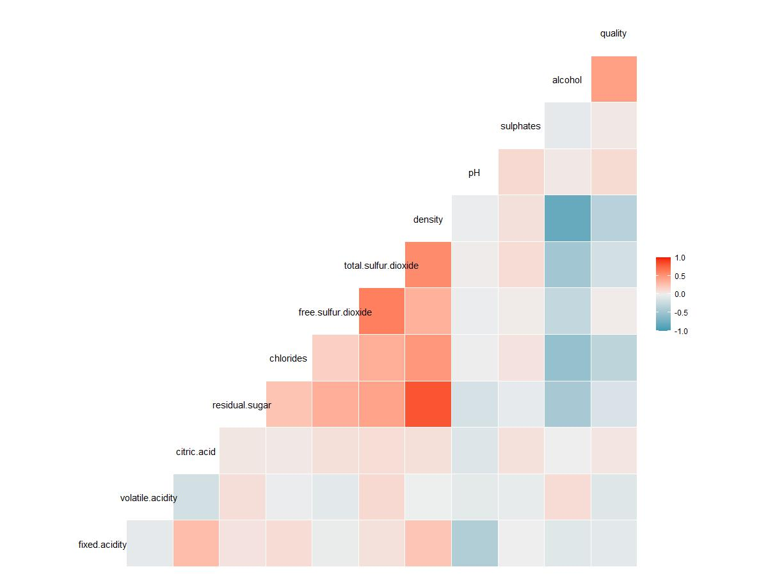

Fig 4: Correlation Matrix of White wine dataset
6

Initial Regression
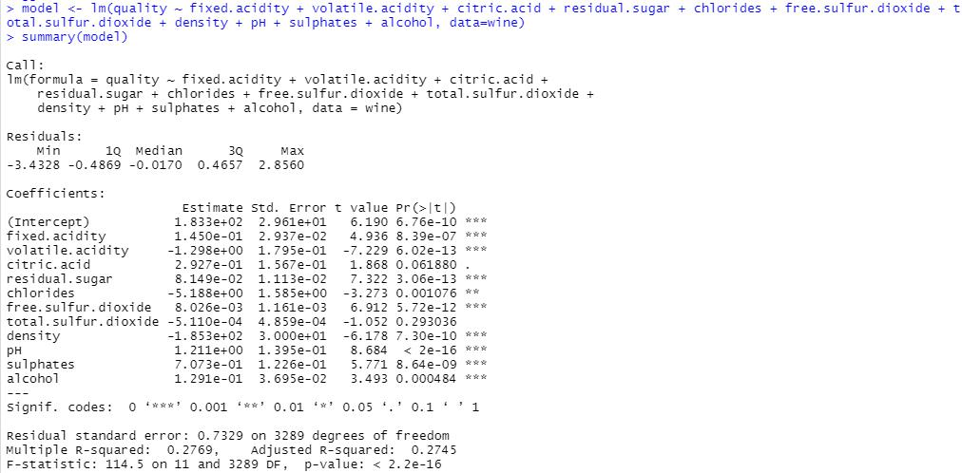
7

Assumptions of Initial Regression

1. Linearity
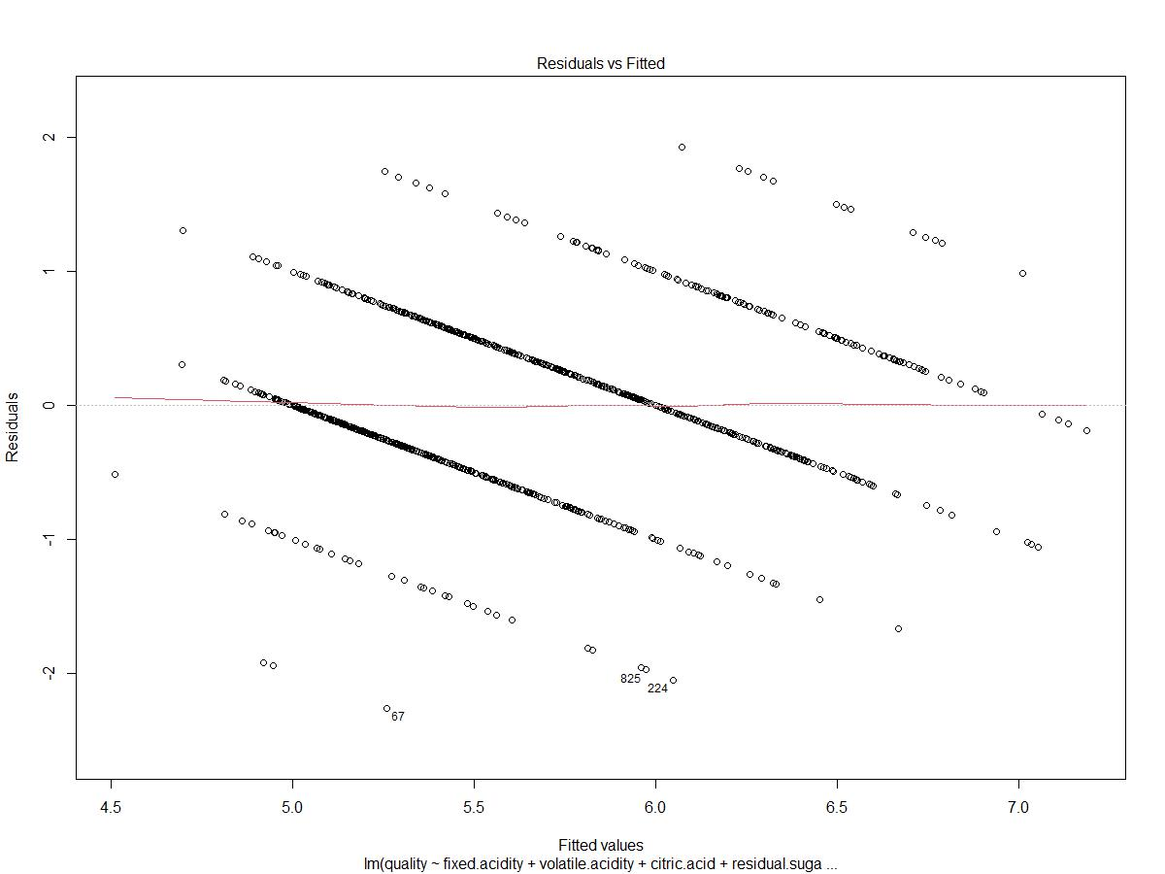

As there is straight line, Linearity holds
8

2. Normality
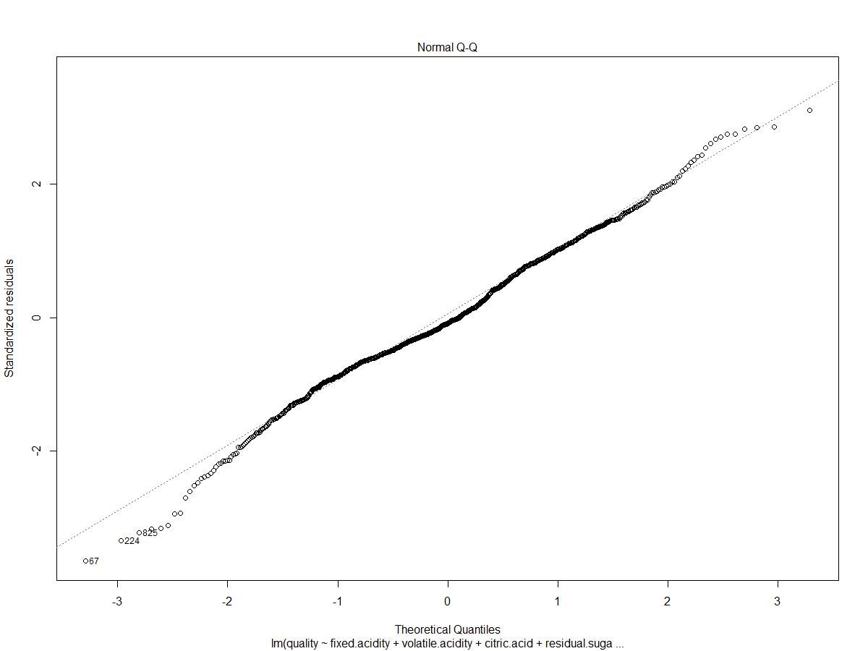

Straight line means normality holds.
9

3. Homoscedasticity
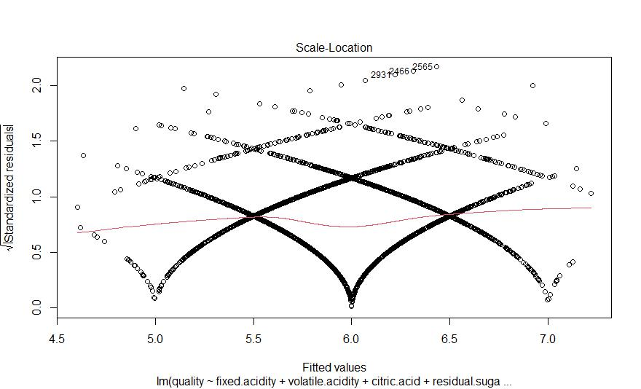

Fairly straight line means linear regressions holds the assumption of homoscedasticity
10

Dropping the variables

Due to the very high value of p-Value we are dropping columns - Citric Acid, Chlorides, Total Sulfur Dioxide.
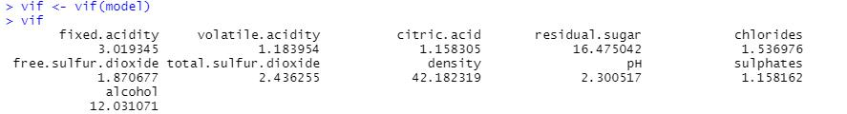

Due to the very high VIF value of Density, dropping density.
11

New Regression Model
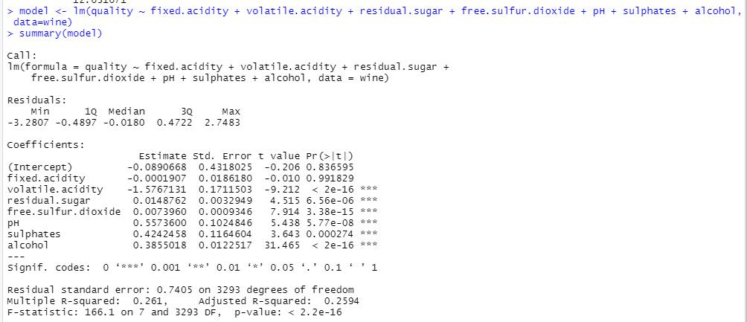

Y = -0.089 -0.001(x1) -1.576(x2) + 0.014(x3) + 0.007(x4) + 0.557(x5) + 0.424(x6) + 0.385(x7)

Y = Quality

X1 = Fixed Acidity

X2 = Volatile Acidity

X3 = Residual Sugar

X4 = Free Sulfur Dioxide

X5 = pH

X6 = sulphates

X7 = Alcohol

Square R=0.261
12

Red Wine Dataset

Cleaning the Dataset

Initial Data has 1599 observations with 12 columns.

- Removing Duplicate Observations

Now, the new data has 1359 observations with 12 columns.
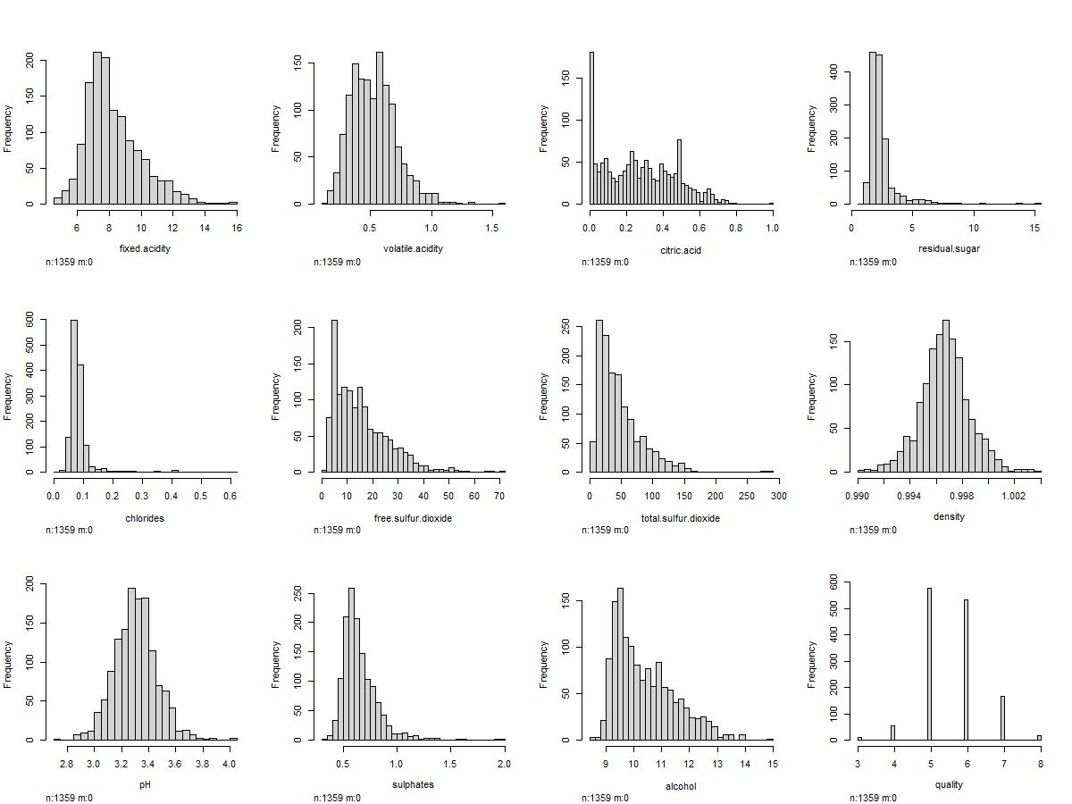

Each column (variable) is fairly distributed.

Removing outliers from all columns (Outside of 1.5x interquartile range)

So updated data has 996 observations with 12 columns.

13
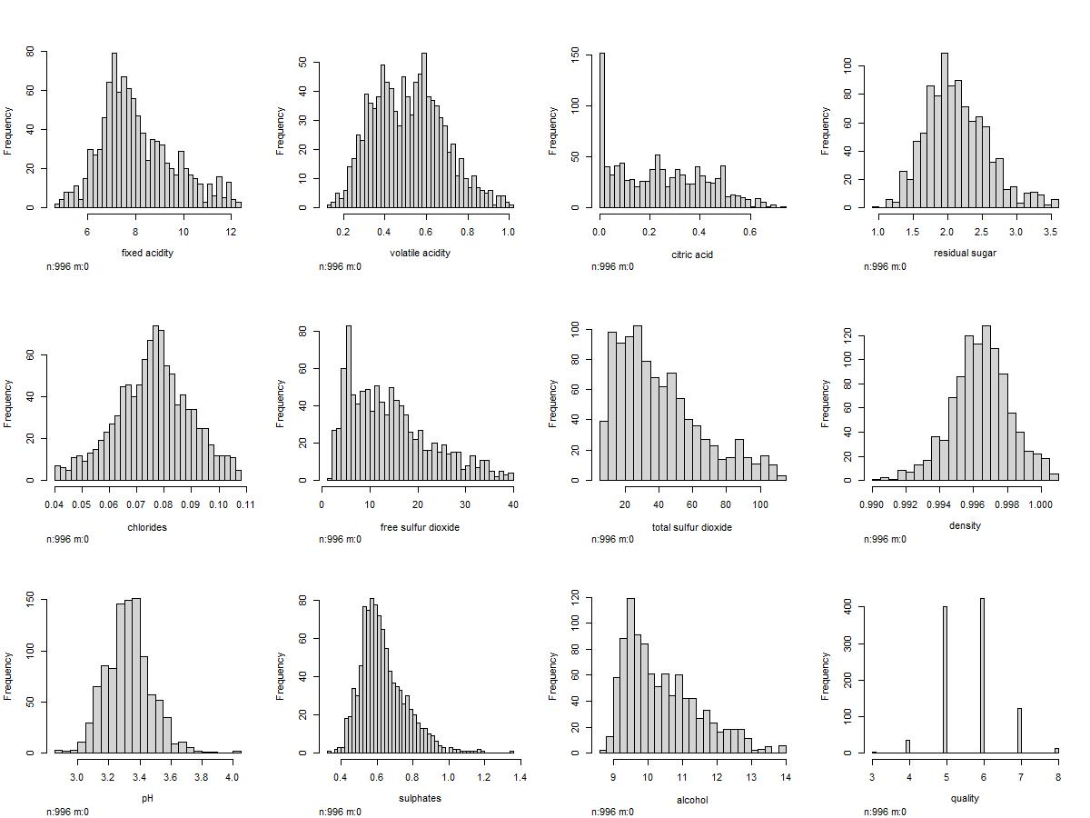
14

Exploratory Data Analysis
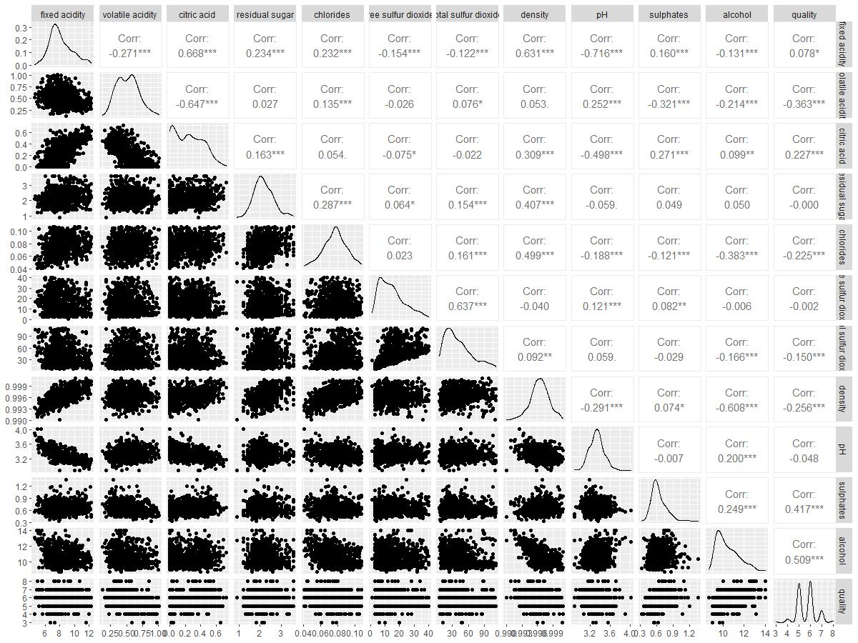
15

Correlation
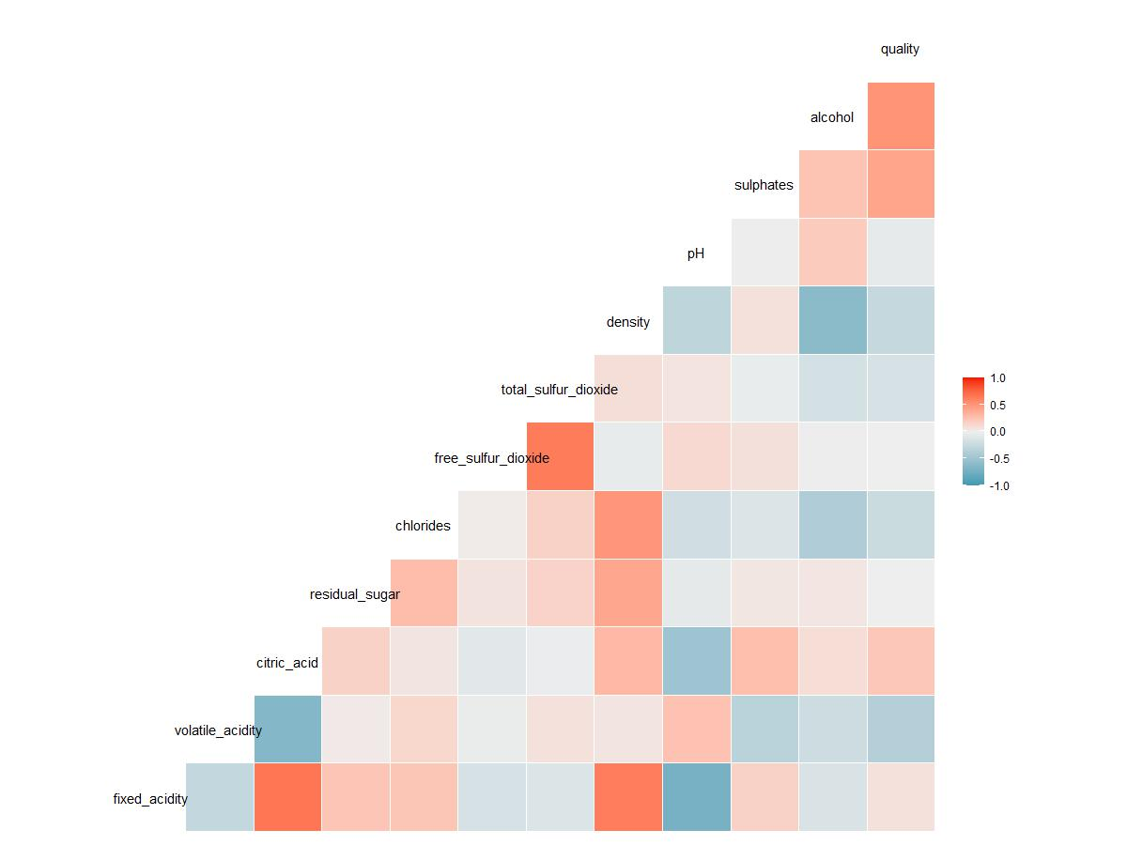
16

Initial Regression
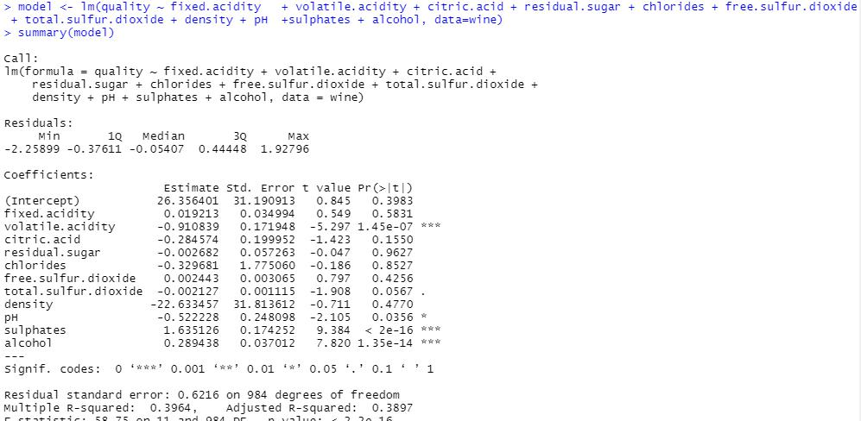
17

Assumptions of Initial Regression

1. Linearity
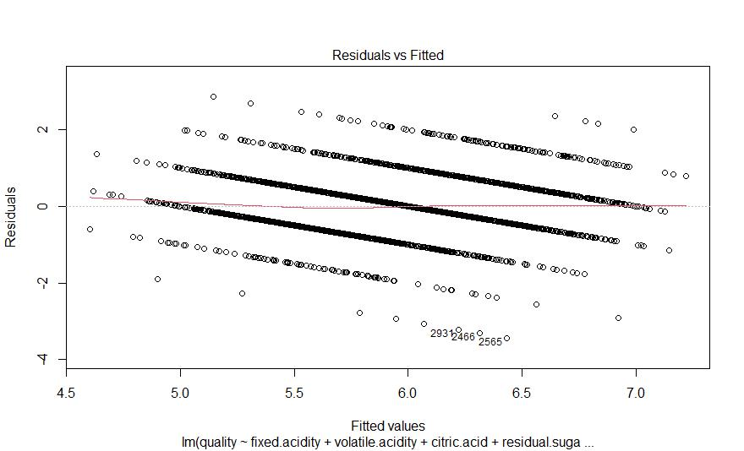

As there is straight line, Linearity holds
18

2. Normality
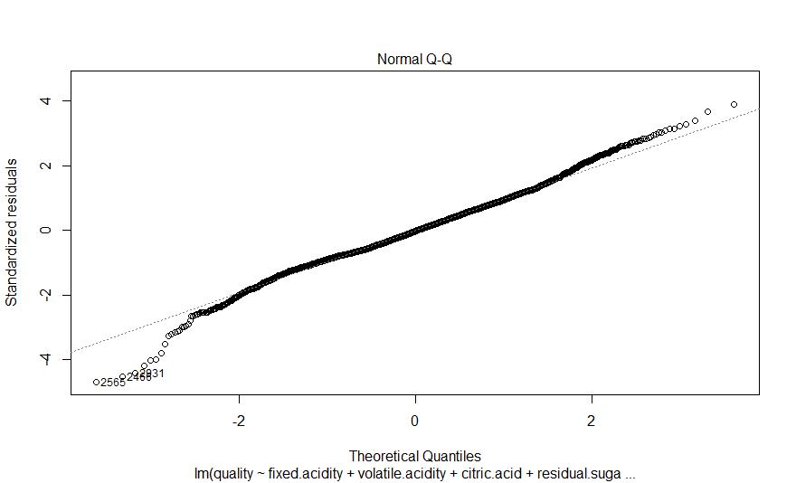

Straight line means normality holds.
19

3. Homoscedasticity
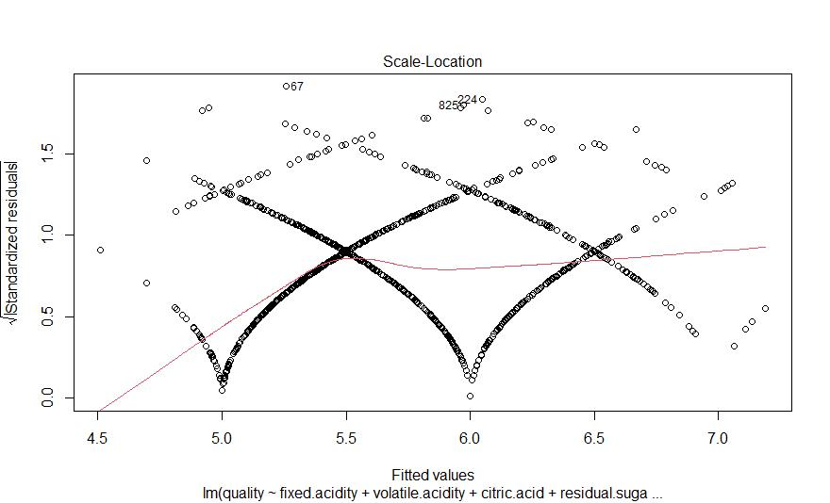

Fairly straight line means linear regressions holds the assumption of homoscedasticity
20

Dropping the variables

Due to the very high value of p-Value we are dropping columns - Fixed Acidity, Citric Acid, Residual Sugar, Chlorides, Free sulfur dioxide, density
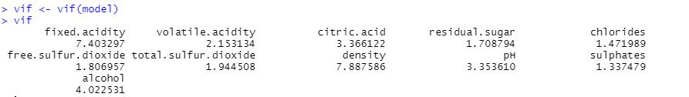

All values of VIF are significantly low.
21

New Regression Model
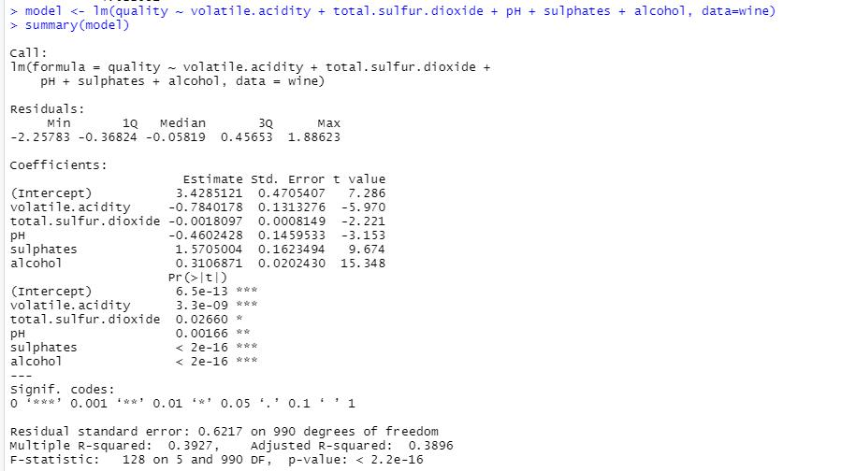

Y = 3.428 -0.784(x1) -0.001(x2) - 0.460(x3) + 1.570(x4) + 0.310(x5)

Y = Quality

X1 = Volatile Acidity

X2 = Total Sulfur Dioxide

X3 = pH

X4 = Sulphates

X5 = Alcohol

Square R=0.3927
22

Additional efforts

We also tried making our model using Logistic regression.

Here’s the link to the report:

https://docs.google.com/document/d/1nhn2nCiePMgIT3oN839W6vvqH4nV0cnTbjVO9an_hJk/e

dit?usp=sharing

